MATIAS CASTRO
W0512163 2025-12-03
pROJECT 2

1. Logical Network Diagram
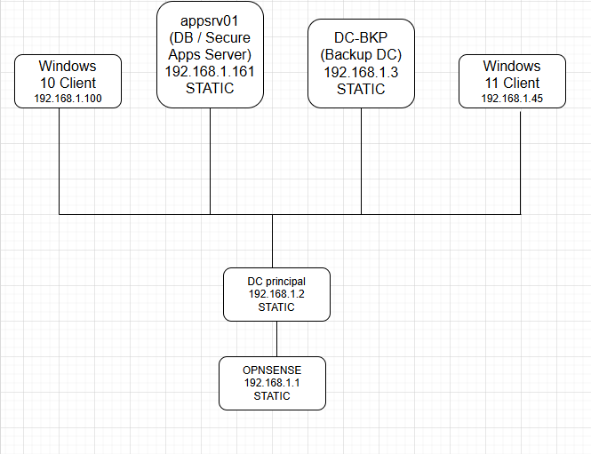
Note: Placeholder diagram to be replaced with your actual network diagram using Visio, draw.io, or PowerPoint.

2. IP Addressing Scheme
Device | IP Address | Type | Notes
OPNsense | 192.168.1.1 | Static | Gateway / Firewall
DC01 (Primary DC) | 192.168.1.2 | Static | AD DS, DNS, DHCP
appsrv01 (DB / Secure Apps Server) | 192.168.1.161 | Static | IIS, FTP, FSRM, NPS
DC-BKP (Backup DC) | 192.168.1.3 | Static | AD DS replica, DNS, Backup share
Windows 11 client | 192.168.1.100 | DHCP | AD-joined client
Windows 10 Client | 192.168.1.45 | DHCP | AD-joined client
DHCP Range: 192.168.1.41 - 192.168.1.245 DNS Forwarders (DC01 & DC-BKP): 1.1.1.1, 8.8.8.8

3. Active Directory & Permissions Design

OU Structure
Domain Name: oscar.net

OU (Organizational Unit) Structure:

oscar.net
- IT MANAGERS→ Full Access to IT resources. Access to sales data and shared folders.
- Employees → Access to management files and reports.

User Accounts:
Username | Full Name | Department | OU | Role
Matias | Matias | MANAGER | IT MANAGERS | Domain Admin
Cr7 | Ronaldo | MANAGER | IT MANAGERS | Manager general
MS10 | Messi | Sales | EMPLOYEES | Sales Department User
Jjose | Jose | Sales | EMPLOYEES | Sales Department User
Daniel | Dani | Sales | EMPLOYEES | Sales Department User

Security Groups
- SG_SecureFTP_Users: For FTP access on appsrv01.
  - Matias
  - Ronaldo

Admin Accounts
- Matias(principal administrator)
- Ronaldo (Domain admin)

4. Server Roles Plan
Server | Roles
DC01 | AD DS, DNS, DHCP
DC-BKP | AD DS replica, DNS, Backup share
appsrv01 | IIS, FTP, FSRM, NPS
OPNsense | Firewall, RADIUS client
Windows Clients | AD-joined clients

5. Group Policy Planning
GPO | Target OU | Purpose
Windows Firewall Logging | Servers | Enable logging for monitoring inbound/outbound traffic
Common Drive Mapping | Users | Automatically map shared folder on appsrv01
Justification: Improves security and centralizes management.

6. Security and Reliability Plan

Redundancy
- DC-BKP ensures AD DS and DNS redundancy.
- Backup share for Primary DC and appsrv01.

Windows Firewall Rules
Server | Open Ports / Protocols
appsrv01 | TCP 80 (IIS), TCP 20/21 (FTP), UDP 1812/1813 (NPS)  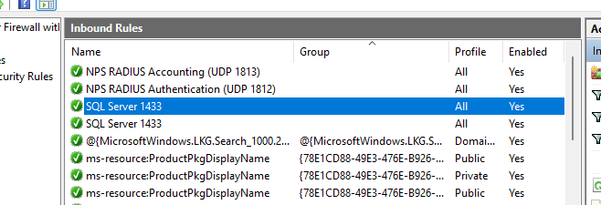
DC-BKP | TCP 135, 389, 636, 3268, 3269 (AD replication), SMB 445 for backup  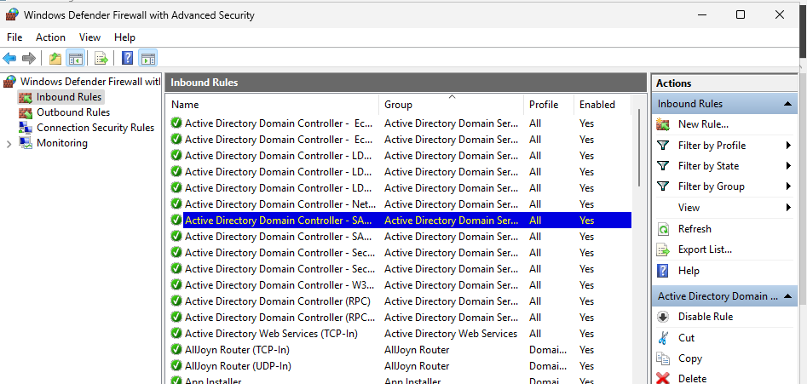

Backup Strategy
- Primary DC: System State → backup share on DC-BKP → daily
- appsrv01: System State + C:_Root → backup share on DC-BKP → daily
- Use Windows Server Backup scheduled jobs.

7.Testing & Verification
Client Connectivity and nslookup
- Successful nslookup
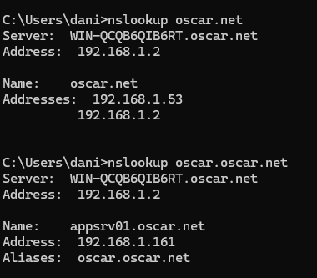
- Successful ping to appsrv01 and Oscar.net
Client windows 11
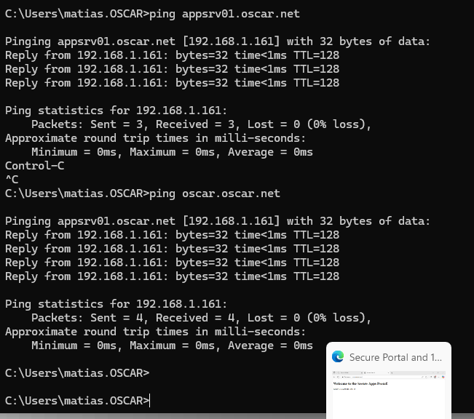
Client windows 10
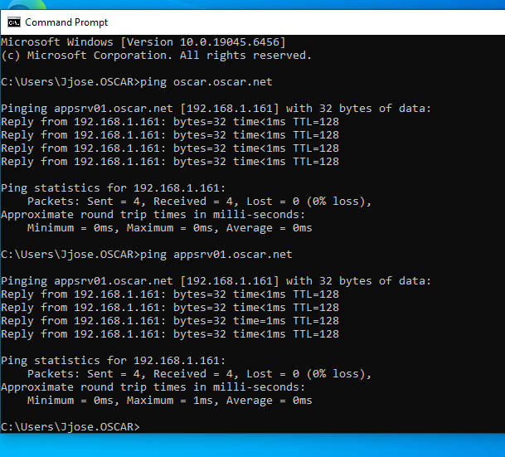
- Internet access verified.
Client windows 11
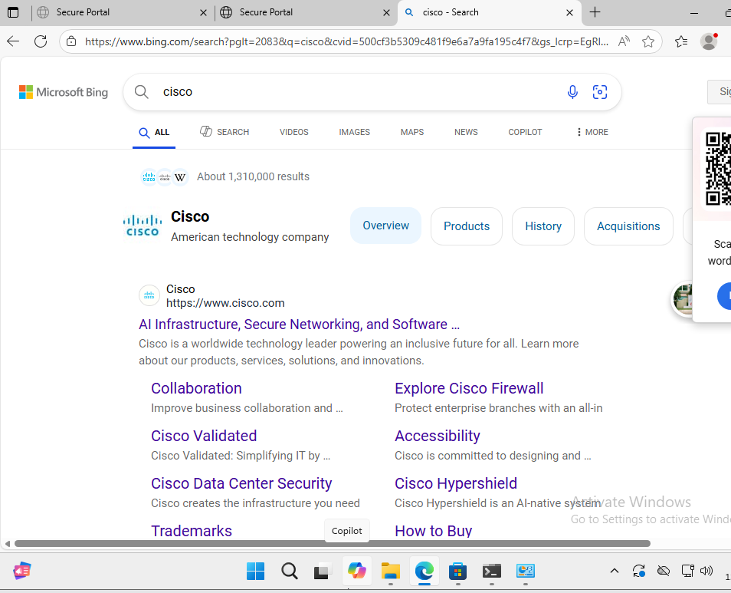
Client windows 10
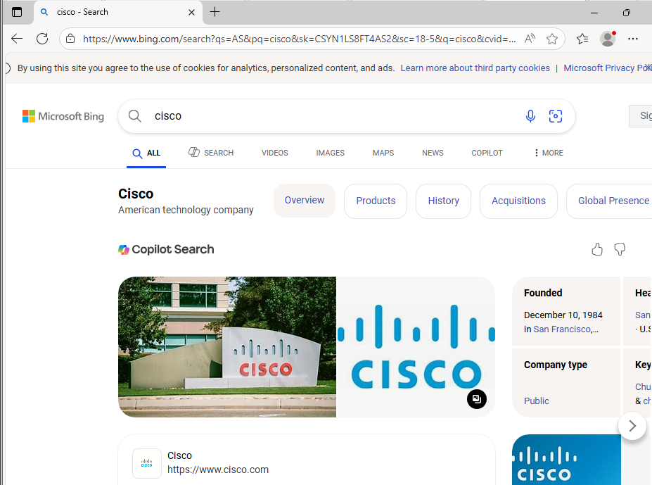
Web Server Verification
- http://oscar.oscar.net loads the internal IIS website.
Client windows 10
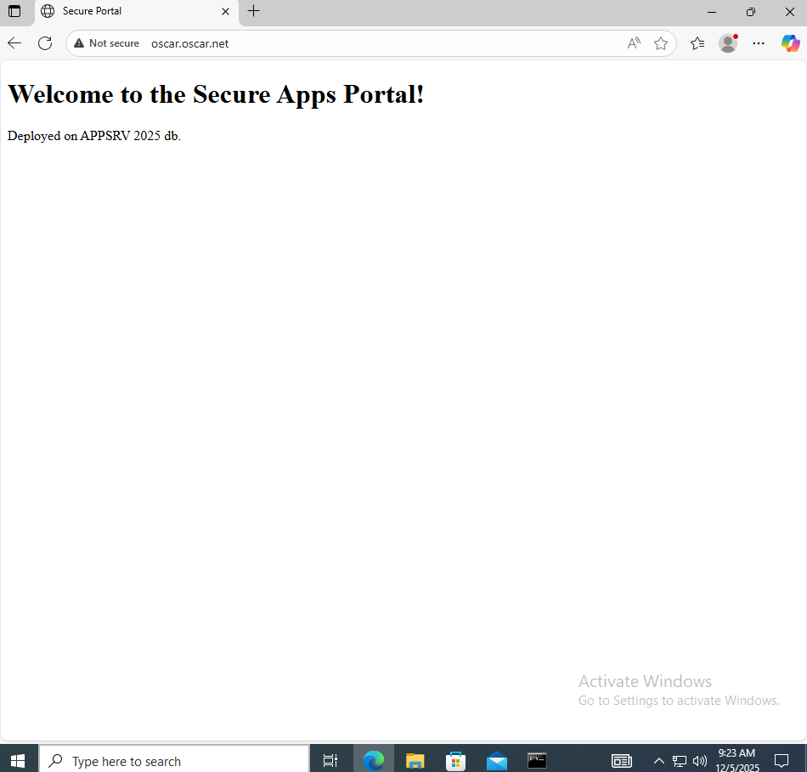

FTP Server Verification
- Authorized user: Matias and Ronaldo
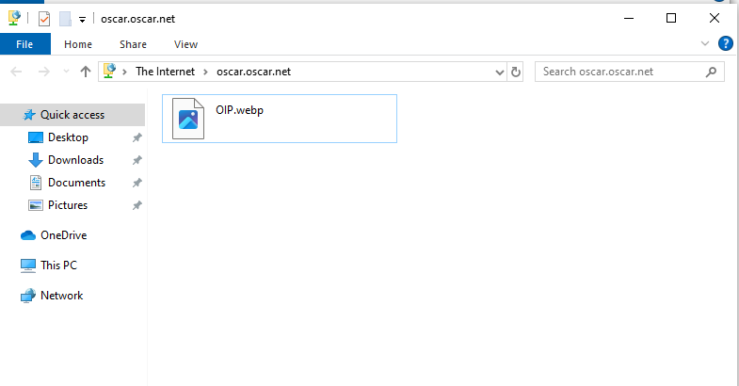
- Unauthorized user: Jose, Daniel and Messi
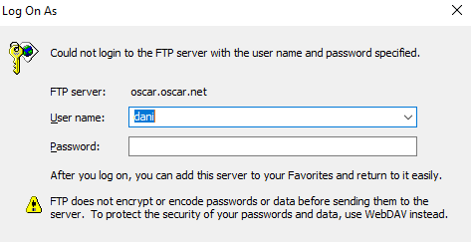

FSRM Tests
- Uploading .exe is blocked.
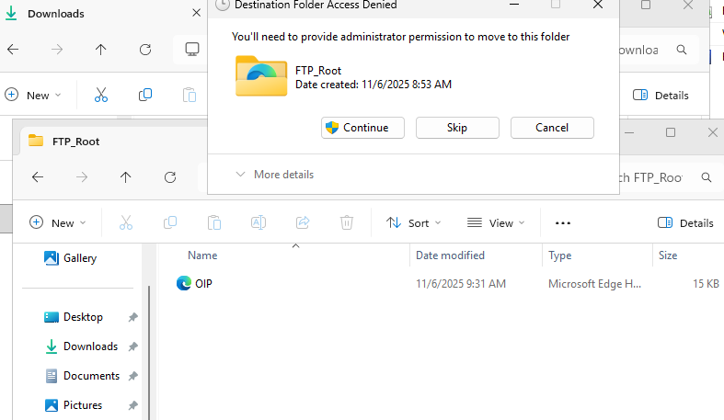
- Quota exceeded tests show denied transfers.
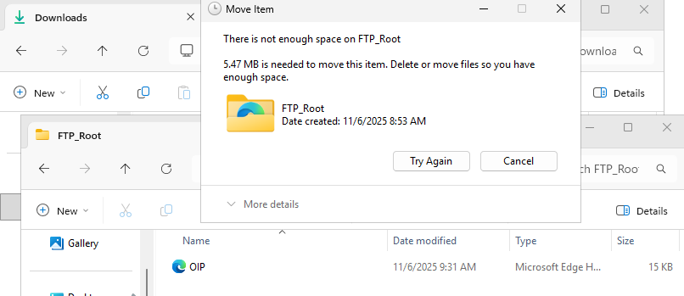

RADIUS (NPS) Verification
- OPNsense Access Tester returns SUCCESS for SG_SecureFTP_Users members.
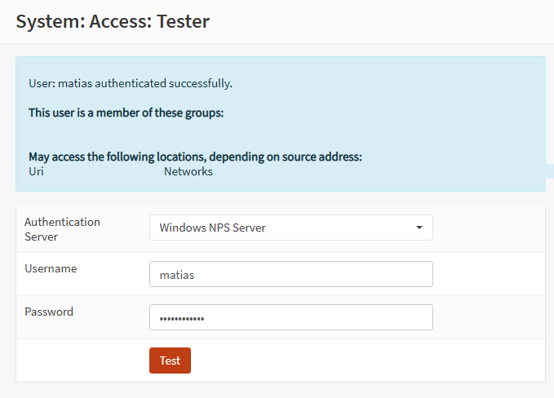
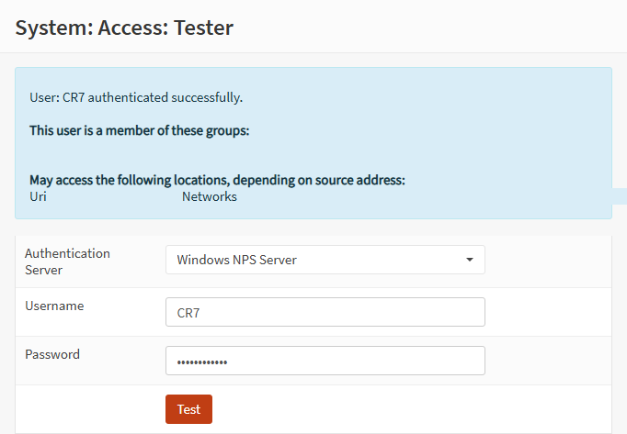
- FAILURE for non-members.
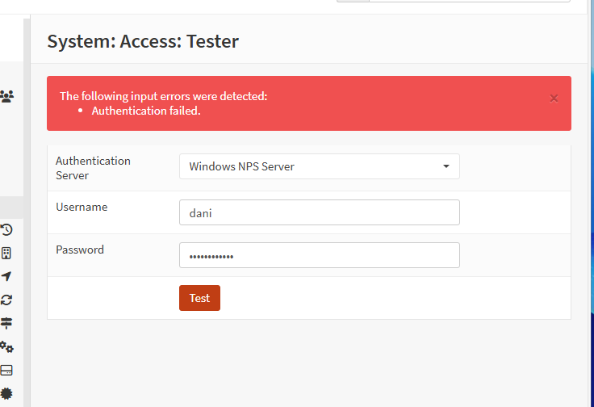
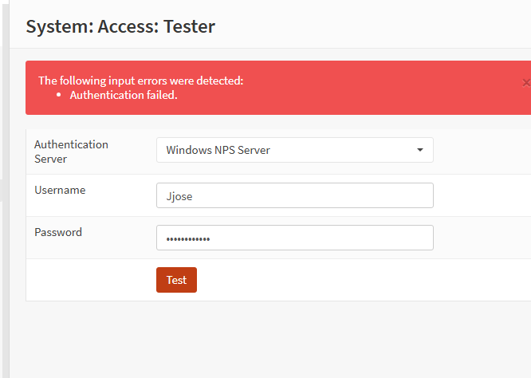
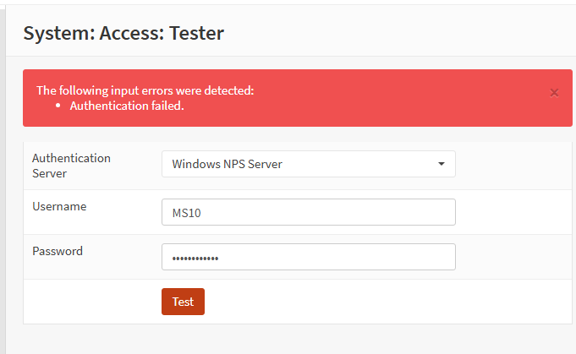

Group Policy Verification
- gpresult /r shows Firewall Logging GPO and Drive Mapping GPO applied.
Jose
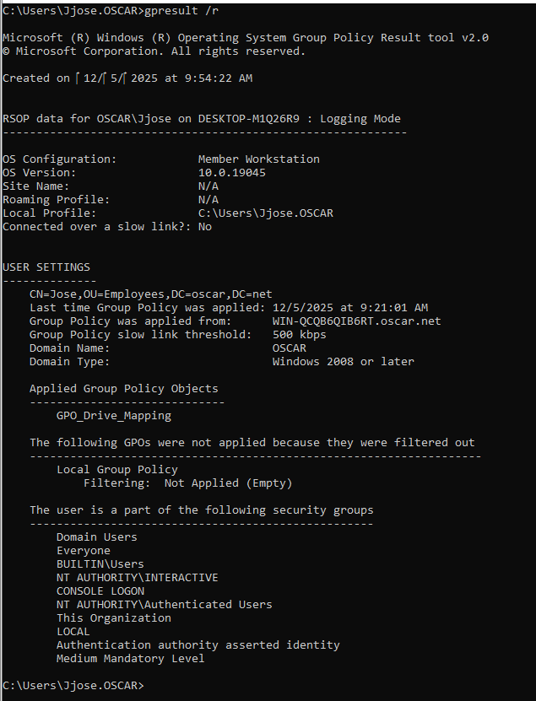
Matias
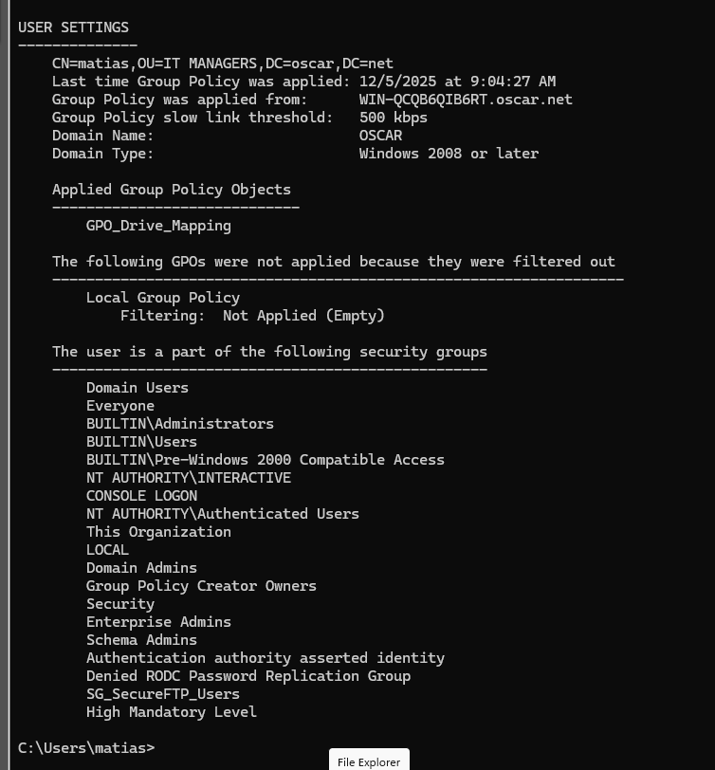
Ronaldo
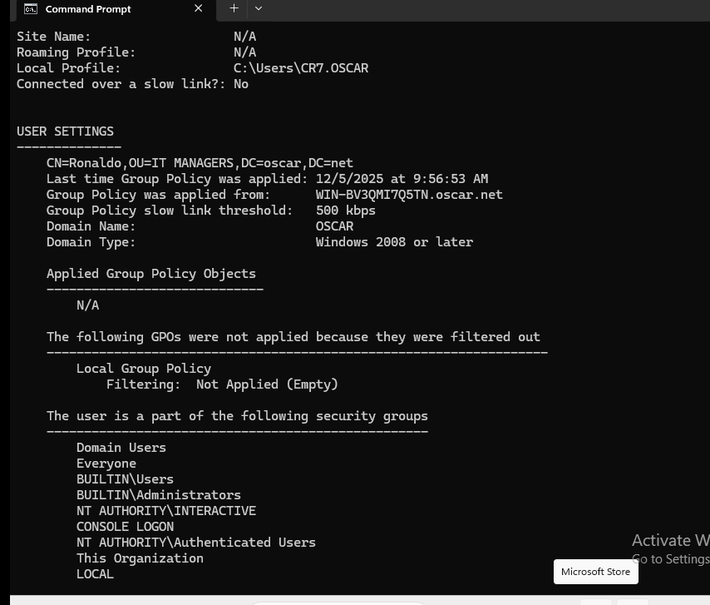
Messi
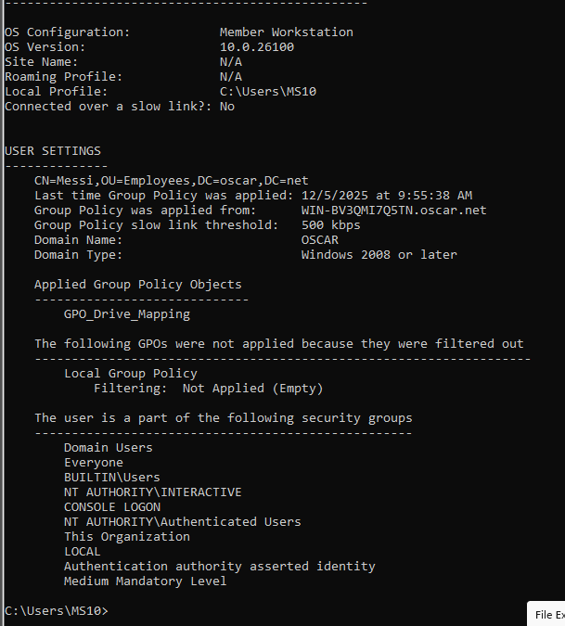
Daniel
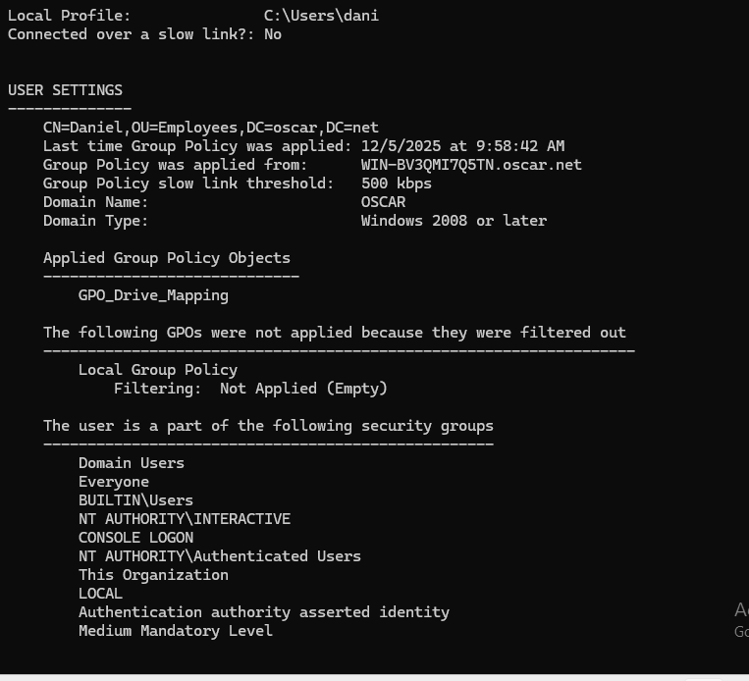

Backup Verification
- Backup tasks run successfully on both DC01 and appsrv01.
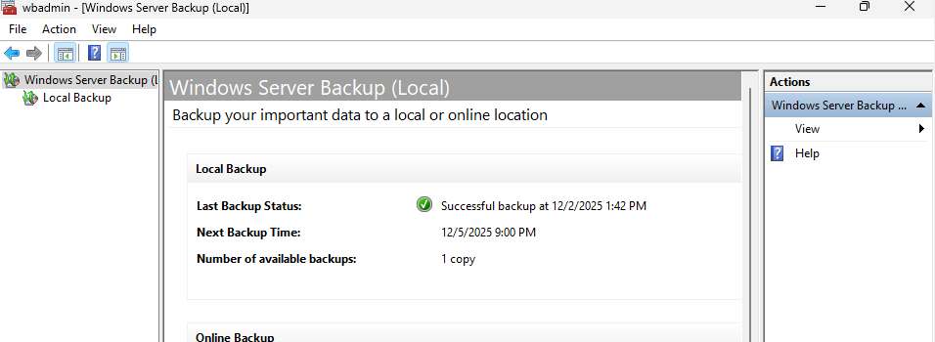
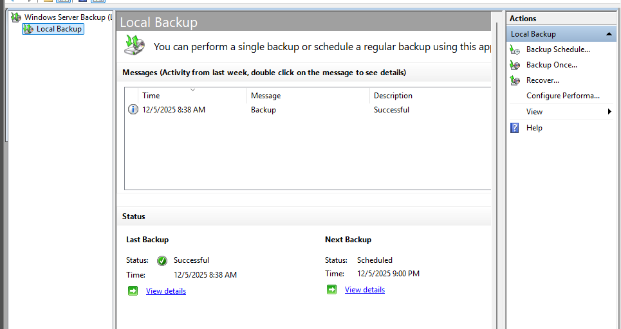
- Backup files visible on DC-BKP01 shared folder.
